

DC Circuit Analysis and Energy Security

Semester 1, 2025 – 2026
Student Name: Arpan K Roy
Student Number: 25022142
Module: APPLICATIONS OF ELECTRICAL AND ELECTRONIC
ENGINEERING 1
Module Leader: Tamoor Shafique
Submission Date: January 9, 2026
Word Count: 4961
Contents
DC Circuit Analysis and Energy Security 1
Abstract 3
Introduction 3
Research question 4
(a) Energy Security Risks: Fossil Fuels vs Renewables 4
(b) Electrification, Grid Interconnection, and Cross-Border Energy Trade 4
(c) Green Hydrogen: Global Trade and Energy Security Implications 4
(d) Geopolitical Shifts from the Transition to Renewables 5
(e) Cyber and Physical Security in Renewable Energy Systems 5
(f) Climate Change, Adaptation, and Renewable Energy Systems Resilience 6
(g) Multi-dimensional challenges of energy security. 6
Conclusion 7
THEMATIC ANALYSIS 8
(a) Themes in Global and UK Energy Security 8
(b) Contrasting Global and National Priorities 8
(c) Policy and Engineering Implications 8
(d) Strengths and limitations of using thematic analysis. 9
Task Overview 10
Task 1 10
(a) SW1 and SW2 open 10
(b) SW1 switch closed 12
(c) SW1 and SW2 closed 15
Task 2 18
Conclusion 20
Overall Conclusion 21
References 22
Figures
Figure 1. Voltage and Current readings when SW1 and SW2 are open. 12
Figure 2. Resistance reading when SW1 and SW2 are open. 12
Figure 3. Voltage and Current readings when SW1 is closed. 15
Figure 4. Resistance reading when SW1 is closed. 15
Figure 5. Voltage and Current readings when SW1 and SW2 are closed. 18
Figure 6. Resistance reading when SW1 and SW2 are closed. 18
Figure 7. Voltage and Current readings. 20
Figure 8. Wattage Rating. 21

Abstract
This report evaluates the relationship between renewable energy transitions and energy security, taking insights from the International Renewable Energy Agency’s (IRENA,2024) Geopolitics of the Energy Transition: Energy Security report and the UK Energy 2024 publication. The study examines the shift from fossil fuels to renewable energy systems by redefining the traditional aspects of energy stability, resilience, and affordability. A thematic analysis is conducted from both global and national perspectives, which highlights the challenges faced, geopolitical realignments, new critical earth mineral dependencies, and the need for equal access to energy. The technical part of the report applies DC circuit analysis using Ohm’s laws and Kirchhoff’s laws to calculate the total resistance, branch currents flowing through resistors, and the voltage drops around a circuit, backed by Multisim simulations. The data proves the theory is accurate and highlights the necessity of analytical precision to ensure reliability. Overall, the report connects the global energy transition to the practical engineering principles necessary for building resilient, secure, and sustainable energy systems.

Introduction
Everyone is dependent on energy in one way or another in modern society, from the heating and lighting in our homes to industrial production and digital communication. It's reliable and affordable, which makes it central to energy security, as defined by the International Renewable Energy Agency (IRENA,2024), “uninterrupted availability of energy sources at an affordable price.” As nations transition towards renewable energy systems, sustaining this reliability has become very complex due to factors such as cyber vulnerabilities, demand for resilient infrastructure, and Unpredictable Power. This report critically analyses energy security, evaluating how renewable energy is reshaping the global energy systems while applying DC circuit analysis. The report has four aims:
(i) Critical Analysis of Energy Security and the Energy Transition, the transition to renewable energy, as highlighted by IRENA (2024), reshapes energy security by affecting availability, affordability, and reliability, while influencing geopolitical dependencies and national trades.
(ii) Comparison Between IRENA and UK Reports, the IRENA (2024) and UK Energy 2024 explain themes such as decarbonisation, policies, technological innovation, and resilient infrastructures, showing the difference between UK strategies from global strategies.
(iii) DC Circuit Calculations and Verification using Multisim software, finding total resistance, branch currents, and voltage drops are calculated using Ohm’s Law and Kirchhoff’s Laws, and verified via Multisim.
(iv) Current and Wattage, the current is calculated using Ohm’s Law and Kirchhoff’s Laws, and the wattage rating is found.

Research question

(a) Energy Security Risks: Fossil Fuels vs Renewables
The energy security risk in terms of resource availability is that fossil fuels are limited and finite and are subject to depletion, whereas renewable energy is abundant and has variable flow (Box 2.1, pages 30–31). Fossil fuels are used globally, and most countries are dependent on specific countries and regions, but renewable energy is in lower concentration, which can be formed within a country, meaning it could weaken the alliance formed between nations. (pages 30–31). The Environmental Impact of fossil fuels is very high; in contrast, renewable energy is clean energy, meaning it has a low environmental impact. (pages 29–31). Disruptions caused in the infrastructure used to obtain fossil fuels could have a higher impact as compared to clean energy, indicating clean energy has higher resilience to disruptions (Box 2.1, pages 30–31). Affordability, which plays a big role, fossil fuel systems are very developed, which makes them cheaper in the short term, whereas renewable energy is an up-and-coming idea, hinting it has more of an up-front cost, but in the long term, it will be cheaper to operate and keep it running, in addition to that, it is very beneficial to the environment as compared to fossil fuels. (Box 2.1, pages 30–31). Over time, the cost of renewable energy systems to set up keeps dropping, making it affordable than before (Box 2.1, page 31). In contrast, prices of fossil fuels are skyrocketing. (pages 20,30). Though some underdeveloped countries may still face the problem of affording equipment and systems to promote clean energy.

(b) Electrification, Grid Interconnection, and Cross-Border Energy Trade
Many countries are dependent on oil and gas from fossil fuel-rich countries, but in the case of electricity trade, it is viewed more as a balanced partnership, rather than one-sided dependence seen in traditional oil and gas relationships. (pages 42–43;64–66). Synchronisation is one of the primary challenges in interconnecting grids, which involves aligning the frequencies of generation facilities in the connected systems. (page 65). After the war between Russia and Ukraine surfaced, both Ukraine and Moldova synchronised their grids with that of Europe. (pages 66–67). Baltic states are synchronised to the Russian and Belarusian grids due to historical reasons, but soon they are to be set with the same continental European Grid. (pages 65–67). Cross-border outages can risk rippling through the entire network, though they allow shared benefits. (pages 65–67). Such events that have already occurred were in North America in 2003, Europe in 2006, and India in 2012, which have led to blackouts affecting millions of people. (page 67). These events were within the national grids, but in the case of a cross-border interconnecting grid, the risks could extend. Non-delivered amounts of electricity require energy-generating capacities because storing electricity is difficult in larger volumes for longer periods of time. (pages 64–66). Increase in electrification and expansion of cross-border energy trade call for a strategic reassessment of what is considered an asset in a decarbonised and regionalised energy landscape. (page 69). In short, interconnectors and electrical grids emerge as critical nodes for ensuring energy security. (pages 65–70).

(c) Green Hydrogen: Global Trade and Energy Security Implications
Green hydrogen is rising as a key player in future energy systems, offering opportunities and challenges for the global energy trades and energy security. (pages 73–74). According to the IRENA 2024 report, hydrogen is a substitute for fuel and has potential in reshaping global energy systems. It provides a pathway to decarbonise sectors that are hard to electrify, like steel, cement, and heavy transport, while it also creates new forms of trade and geopolitical relations built on clean energy. (pages 75–76). Green hydrogen offers to diversify energy supplies and reduce dependence on fossil fuel imports. Hydrogen can be produced almost anywhere if there is access to renewable energy and water, providing countries an opportunity to produce energy that lacks in fossil reserves. (pages 76–78). Regions like the Middle East, North Africa, and parts of Latin America could evolve into major hydrogen producers that can transform their economy. However, IRENA also informs that the challenges that come with it, large-scale production, storage, and transportation, could remain costly and complex. (pages 80–82). Supply chains would require new infrastructures such as pipelines and ports, meaning countries would need to invest a lot and coordinate globally to avoid imbalance. Geopolitical tensions would also rise due to advanced nations being able to do large-scale development, whereas developing nations would struggle to compete against them. (pages 83–85). Therefore, policies must focus on cooperation and develop the market in such a way as to ensure hydrogen is enhanced. (pages 85–86).

(d) Geopolitical Shifts from the Transition to Renewables
The global shift towards renewable energy is reshaping geopolitical aspects, challenging the influence of exports for fossil fuel-rich nations. For decades, countries rich in oil and gas wielded high geopolitical leverage because many nations are heavily dependent on fossil fuels. (pages 87–89). Energy security was defined by access to fossil fuel resources; however, as the world transitions to renewable energy sources such as wind, solar energy, and green hydrogen, the traditional dependence on energy is disrupted. (pages 89–91). According to IRENA’s Energy Security (2024) report, renewables are much easier to produce and can be produced locally anywhere, considering the region has the necessary resources. (pages 90–91). Countries that had little to no control over their energy supply can now produce energy domestically, gaining more autonomy in energy and economic planning. Simultaneously, critical technologies and materials required for the energy transition are rising. (pages 93–95). Countries such as Chile, China, and the Democratic Republic of Congo, rich in rare earth minerals like lithium, cobalt, are gaining more importance, and countries like the United States of America, China, and some EU members are dominating the renewable technology manufacturing and research is gaining importance as control over renewable technology becomes a vital source of geopolitical energy. The rise of green hydrogen further reshapes the energy geopolitics, allowing nations with abundant solar and wind capacity to become exporters, providing economic growth and more trade opportunities. (pages 73–79). However, nations that lack these resources may be reliant on imports. IRENA emphasises that there needs to be cooperation globally and diversified trades to avoid strategic imbalances. (pages 96–98).

(e) Cyber and Physical Security in Renewable Energy Systems
Energy systems are now more reliant on technology, software, and real-time data. Cybersecurity threats can mess up or disrupt the operations that monitor the grid controls. (pages 100–101). Renewable infrastructures are also exposed to extreme weather conditions like storms, floods, etc, which damage the technology and equipment. Failures in one part of a cross-border grid can disrupt the entire connection that may be connected between many countries, which can cause power shortages as well. (page 102). Remote places or lightly guarded installations are more likely to be affected by theft. Countries rich in renewable technology that contain sensitive data hold more influence, but when other countries and companies use incompatible digital systems, their systems are more likely to get targeted for cyber-attacks, and their sensitive data may get exposed. (pp 100–10). Some strategies to prevent these problems include building infrastructure with hardening properties that withstand the extreme weather conditions, integrating cybersecurity in the early designs of renewable energy systems and using layers of security and coordinating cyber and physical security measures, running drills, as well as training staff. (pages 103–104). Having backup microgrids that can operate autonomously when central systems fail. Security planning should include climate change risks and human aspects, such as energy access, inequality, and energy poverty. Also, using standard data protocols and shared cybersecurity systems can help countries and companies work together better and make their systems less vulnerable to having different setups. (pages 100–103). Governments and private companies should also try to work together and share information so they can react faster to new problems. And finally, making people more aware and involving local communities in energy planning can make the system stronger socially, too, so it doesn’t just survive problems but also keeps giving power to people when there are crises. (page 107).

(f) Climate Change, Adaptation, and Renewable Energy Systems Resilience
Energy security is constantly under the influence of climate change; instances like rising temperatures and extreme weather like floods, storms, and droughts often damage power plants and other infrastructure. (pages 108–110). These disruptions threaten the supply chains, creating economic and social instability. As given in IRENA’s Geopolitics of the Energy Transition: Energy Security (2024) report, traditional views of energy security, focused mainly on fossil fuel access, are no longer enough. Modern systems and infrastructure must be designed in such a way that they to handle climate shocks and changing environmental conditions. (pages 111–113). Shifts in rainfall patterns and wind intensity also play a part in affecting renewable power generation. These trends make energy systems more vulnerable, considering they remain over-centralised. (page 114, centralisation). However, Renewable energy can become a part of the solution. According to IRENA, renewables can “support cost-efficient and reliable solutions for climate adaptation” by creating more flexible and distributed energy networks. (page 115). People can be less dependent on faraway power plants or imported fuels by deploying solar panels, wind turbines, and battery storage in local areas. Microgrid systems can keep essential services running even when cross-border grids/ large networks fail. (page 116). Countries can adapt to climate change and increase their overall energy security by combining renewable energy with storage, smart microgrids, and building resilient infrastructure. Hence, investing in cleaner technologies like green hydrogen, offshore wind, and advanced storage can stabilise supply during extreme weather. (pages 117-118). Regional energy cooperation and grid innovations can also help balance demand and ensure reliability.

(g) Multi-dimensional challenges of energy security.
IRENA emphasises that energy security in a renewable-based system demands a multidimensional lens, meaning major engineering and policy adjustments. The report emphasises that the infrastructure must be modernised, expanded, and strengthened to counter climate impacts, cyber, and physical threats. (pages 120–122). Considering the world is moving away from fossil fuels and switching to renewable energy sources, building grids, storage, and networks that support such energy is essential. As technologies replace fossil fuels, access to critical minerals and components becomes a security concern. (pages 123–124). Ensuring that manufacturing, trade, and placement of renewable energy-generating infrastructures aren’t subjected to geopolitical disruption is very important. The report also draws attention to the energy security social dimensions to ensure that the transitions do not leave the people behind, avoiding a lack of renewable energy (energy poverty), and supporting employment opportunities, as well as equal access to people. (pages 126–128). The report also stresses the importance of cooperation between regions and cross-border electricity trade. Shared grids between countries provide reliability, but also come with a downside of causing more shortages in case one part of the grid breaks down. (pages 129–130). Shared grids also allow countries to balance variable renewable energy supply, which also decreases the dependency on any single source or technology. There is also a need for integrating digitalisation and smart technologies, advanced monitoring, and predictive analysis helps operators respond quicker and take more protective actions, and provides efficiency. (pages 130–131). The IRENA report highlights that the future of energy security is broader, smarter, and more cooperative, demanding a shift away from fossil-fuel paradigms toward integrated, climate-resilient, and socially equitable energy systems. (pages 131–132).

Conclusion
In conclusion, the shift from fossil fuel to renewable energy changes our opinion on keeping our energy systems safe and reliable. Which means it’s not just about having enough fuel anymore, but rather about building networks that can handle climate changes, physical threats, cyber threats, and the increase and decrease in supply and demand. By investing in solar panels, wind turbines, microgrids, and other renewable technologies, countries can generate energy locally and reduce their dependence on nations that produce fossil fuels. At the same time, many challenges can be faced with this transition, like managing the grids, protecting critical minerals and materials, and ensuring equal access to energy for the people. By combining strategies like regional cooperation, sharing of technology, policies, and strong infrastructure, countries can create energy systems that are much cleaner, reliable, and resilient. This also strengthens connections that countries have with others. Together, these themes illustrate that energy security in the renewable era is no longer a single-issue challenge, but an interconnected system where technology, policy, and infrastructure resilience must evolve in parallel.

THEMATIC ANALYSIS

(a) Themes in Global and UK Energy Security
Supply chain and resource security, IRENA highlights that in a renewable system, energy security isn’t about having abundant oil or gas anymore, rather it's more about the access to the critical materials needed, technology, and strong infrastructure (IRENA, pages 123–125). Minerals like lithium, cobalt, and rare earth minerals are more essential to keep energy flowing (UK Energy, pages 8–9). The report supports this by showing data on rising import dependence and the challenge of securing the key energy inputs.
System flexibility, infrastructure resilience, and decentralisation, IRENA stresses that renewable energy is variable by nature, so grids need to be more flexible, resilient, and smart to withstand extreme climates, cyber threats, and physical threats (IRENA, pages 111–113). Microgrids, storage systems, and other mechanisms help regions stay powered even when large networks fail. The UK report supports this by highlighting how the shifts in energy generation and increasing renewable share are already reshaping the infrastructural needs (UK Energy, pages 15–17).
Geopolitical and trade relationships, IRENA explains the transition, reordering the global influence. Countries with abundant renewable resources or rich in critical minerals, like China, Chile, and the Democratic Republic of Congo, are gaining importance in contrast to fossil fuel-rich countries (IRENA, pages 89–93). UK data shows that the country is reliant on imported low-carbon technologies, illustrating that trade and geopolitics are deeply linked to energy security (UK Energy, page 9).

(b) Contrasting Global and National Priorities
IRENA emphasises on a global scale how the energy transition is reshaping the world’s energy system. It highlights the challenges, such as access to the critical minerals, the need for resilient and flexible grids, geopolitical influence, and social inclusion (IRENA, pages 65–70;90–91). The report mentions the interconnections between countries, the cross-border electricity trades, the rise of new energy powers, and the potential incoming risks of supply chain bottlenecks. For instance, IRENA points out that as the fossil fuel dependence declines, new dependence on earth minerals like cobalt, lithium rises (IRENA, pages 123–125). These affect countries differently depending on their resources, industrial capacity, technological advancements, and alliances. It also mentions that energy security only matters if the transition is equitable and doesn’t leave any community behind (IRENA, pages 126–128).
In contrast, the UK focuses on practical, data-based information within one country. It provides statistics on energy production, consumption, imports, and fuel poverty, showing the UK’s dependence on imported energy and its increasing share of renewables. While it also explains little about the infrastructure resilience, it doesn’t explore the broader geopolitical implications. The UK report shows the shift from domestic fossil fuels to imports of low-carbon technologies, but doesn’t discuss global power shifts on how other countries' energy strategies could affect the UK.

(c) Policy and Engineering Implications
Supply chain and resource security explain the need for strategic planning for the critical minerals of our earth, renewable technology, and efficient infrastructure. The government must realize the potential slowing down of the mineral accessibility like lithium, cobalt, and other rare earth minerals (IRENA, pages.123–124), while investors in energy technology need to invest more in areas where it’s much more feasible and they should build strong supply chains, ignoring these would create new vulnerabilities even as dependence on fossil fuel declines (UK Energy, pages.8–9).
The significance of system flexibility and infrastructure resilience highlights the importance of modernising and building grids that adapt to climate change, as well as being strong enough to handle cyber-attacks and physical threats (IRENA, pages 111–113). Hence, Policymakers should plan more for integration of storage problems, microgrid placements, and quick response mechanisms, ensuring that the system can withstand extreme climates, cyber, and physical threats (UK Energy, pages 15–16). Energy stakeholders must prioritise monitoring digitally rather than physically, predictive analytics, and generating electricity to the nearest point of use rather than relying solely on large power plants to maintain reliable power for consumers.
The geopolitical and trade relationships reflect how the balance of power in the global energy scenario is switching. Instead of being dominated by the exports from fossil fuel-rich countries, the future could be shaped by countries leading in renewable technology, and other resources required for renewable energy (IRENA, pages 89–93). For the policymakers, engaging in creating alliances, supporting fair trade in clean energy, and ensuring that developing countries benefit from the transition rather than being left behind.

(d) Strengths and limitations of using thematic analysis.
Thematic analysis is one of the most useful ways to understand issues like energy security. It helps take a huge amount of technical and political information and provides a clear idea (IRENA, pages 10–12). Themes like supply chain and resource security, system flexibility and resilience, and geopolitical relationships make it easier to understand how the different parts of renewable energy systems are connected. Thematic analysis reveals the real meaning behind data and statistics, which include real-time data about what challenges countries are facing and opportunities they can reflect on and build on. For instance, both reports highlight the crucial earth minerals like lithium, cobalt, and other rare earth minerals, and how they play a role in promoting clean energy. IRENA looks over this at a global scale, pointing out the competition for these critical earth minerals and how they affect political views, while the UK Energy report briefs more about the national energy and how the UK can build its own renewable infrastructures (IRENA, pages 123–125; UK Energy, 2024, pages 8–9).
However, thematic analysis also has its own weaknesses as it relies on interpretation, and it can be a bit subjective; one researcher might focus on the technology, while the other may focus on the social justice or even just political views. It also describes the patterns rather than measuring them, meaning it doesn’t provide an exact measure of how a certain risk might be (IRENA, page 13). But even with these limitations, thematic analysis still provides incredible value. It builds the gap between data and people, on both a global and a local basis. When used in the right and efficient way, policymakers and experts can see the human, social, and environmental reality rather than just the technical challenges of the renewable energy transition.

Task Overview

Task 1

(a) SW1 and SW2 open
In the given circuit, with both switches SW1 and SW2 open, the resistors R1 (2.2 kΩ), R2 (1 kΩ), and R3 (3.3 kΩ) are connected in series and function to limit and divide the current. The total resistance, branch currents, and voltage drops are calculated and verified using Kirchhoff’s Voltage and Current Laws. The simulation results match the theoretical values, confirming the accuracy of the analysis.
- The three resistors $R_{1} , R_{2 }, and R_{3}$ This setup acts as a voltage divider and limits the current drawn from the 12V DC source.
- Aim: To measure the total resistance of the circuit while SW1 and SW2 are open.
Three resistors of values 2.2 kΩ, 1 kΩ, and 3.3 kΩ are used in this case,
Total resistance in the circuit is,
$R_{t}=R_{1}+R_{2}+R_{3}$
=2.2+1+3.3
=6.5 kΩ
=6.5$×$10³ Ω
=6500 Ω
- $I=\frac{V}{R_{T}}$=0.0018462 A
=1.8462 mA

- $V_{1}=I×R_{1}$=0.0018462$×$2200=4.06154 V
$V_{2}=I×R_{2}$=0.0018462$×$1000=1.84615 V
$V_{3}=I×R_{3}$=0.0018462$×$3300=6.09231 V
Checking if the values are right:
$V_{1}+V_{2}+V_{3}$=4.06154+1.84615+6.09231=12 V
- Kirchhoff’s Voltage Law (KVL) states that the sum of all the voltage drops around any closed loop in a circuit is equal to zero.
Total voltage of circuit–three drops=12–(4.06154+1.84615+6.09231)
=0 V

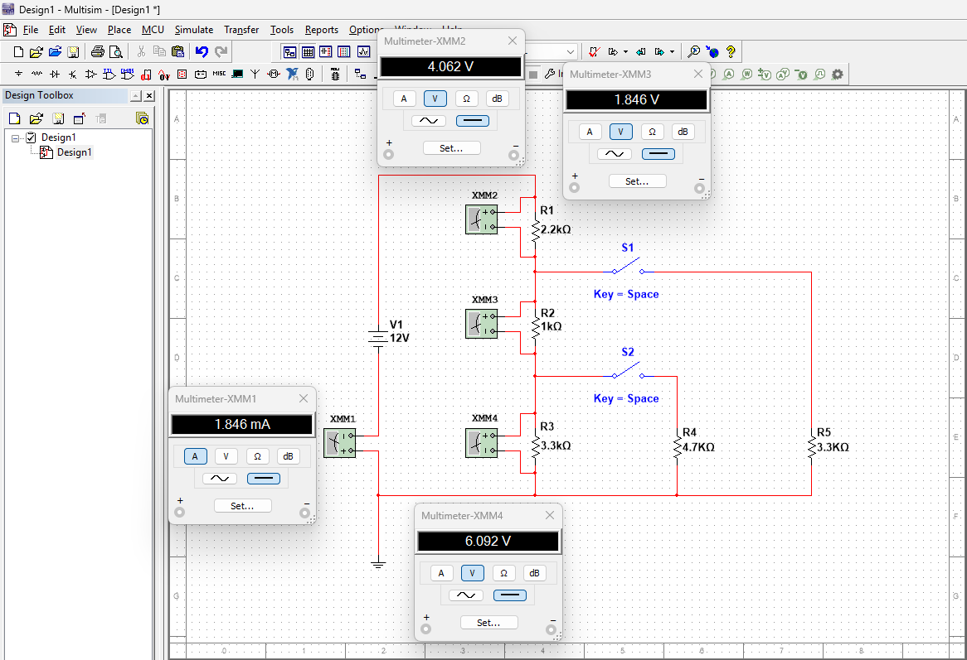
Figure 1. Voltage and Current readings when SW1 and SW2 are open.
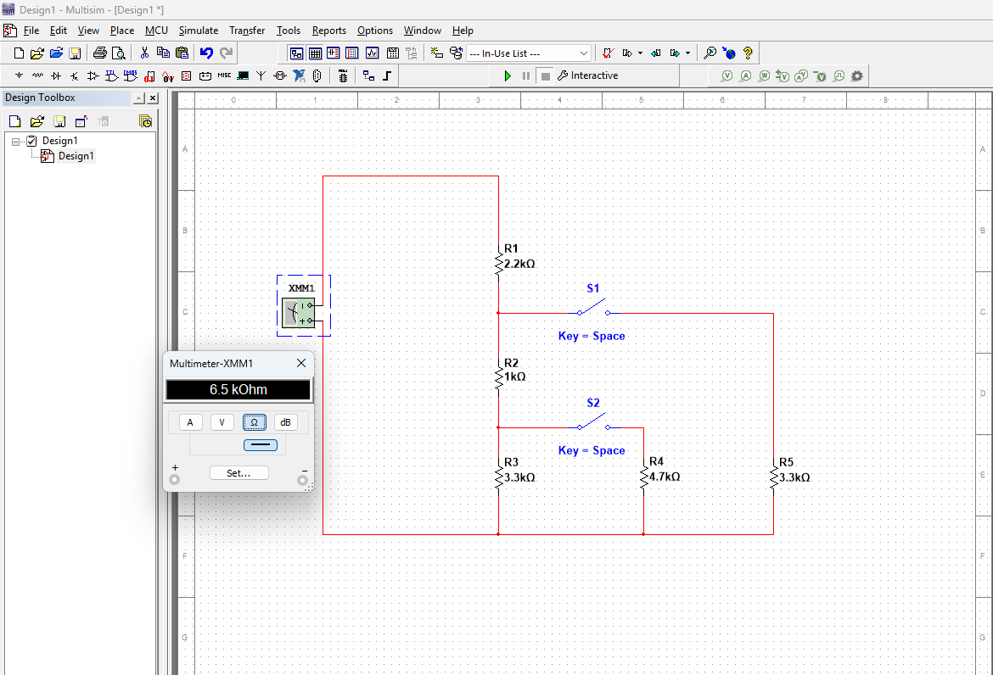
Figure 2. Resistance reading when SW1 and SW2 are open.

(b) SW1 switch closed
When switch SW1 is closed, the circuit configuration changes, which affects the total resistance and current distribution, because R2 and R3 in series are in parallel with R5, and this combination is in series with R1. Application of Kirchhoff’s Voltage and Current Laws confirms the accuracy of the calculated values, and simulation results match the theoretical values.
- Total resistance in the circuit is,
($R_{2} and R_{3}$ are in series)
$R_{s}=R_{2}+R_{3}$=1 kΩ+3.3 kΩ
=4.3 kΩ
=4.3x10³ Ω
=4300 Ω
Parallel of 5 + 2 and 3 in series,
$$\frac{1}{R_{p}}=\frac{1}{4300}+\frac{1}{3300}$$
$$\frac{1}{R_{p}}=\frac{3300+4300}{3300×4300}$$
$$R_{p}=\frac{3300×4300}{3300+ 4300}$$

$R_{p}$=1.867.1052 Ω
$R_{t}=R_{1}+R_{p}$
=2200+1.867.1052
=4067.10526 Ω
=4.067 kΩ
- Total current,
$I_{t}$ = $\frac{12}{4067.10526 }$
=0.0029505 A
=2.9505 mA
At the junction after the R1 current splits,
Consider the top of parallel branches as junction A
$V_{A}$=12–($I_{t}×R_{1}$)
=12–(0.0029505$×$2200)
=12–6.4911
=5.50897 V
Branch current,
$R_{5}$, $I_{5}$ = $\frac{V_{A}}{R_{5}}$
= $\frac{5.50897}{3300}$
=0.0016694 A
=1.6694 mA
Through a series,$R_{2}+R_{3}$,
$I_{23}$=$\frac{V_{A}}{R_{2}+R_{3}}$
=$\frac{5.50897}{4300}$
=0.0012811 A
=1.2811 mA
Checking if the values are right:
$I_{5}$+$I_{23}$=1.6694+1.2811
=2.9505 mA (equal to $I_{t}$)
- Volt drops,
Across $R_{1}$,$V_{1}$=$I_{t}$ $×$ $R_{1}$
=0.0029505$×$2200
=6.491103 V
Across $R_{5}$,$V_{5}$=$I_{5}×R_{5}$
=1.6694$×$3300
=5.508897 V (equal to VA)
Across $R_{2}$,$V_{2}$=$I_{23}×R_{2}$
=1.2811$×$1000
=1.281139 V
Across $R_{3}$,$V_{3}$=$I_{23}×V_{3}$
=1.2811$×$3300
=4.227758 V
Checking if the values are right,
First loop,$V_{1}$+$V_{5}$=6.491103+5.508897
=12 V
Second loop,$V_{1}$+$V_{2}$+$V_{3}$=6.491103+1.281139+4.227758
=12 V
- KCL at the top junction, incoming total current $I_{t}$=outgoing current $I_{5}$+$I_{23}$
2.9505 mA=1.6694+1.2811 mA
=2.9505 mA
KVL around either of the loops sums to zero; both checks above equal 12V.

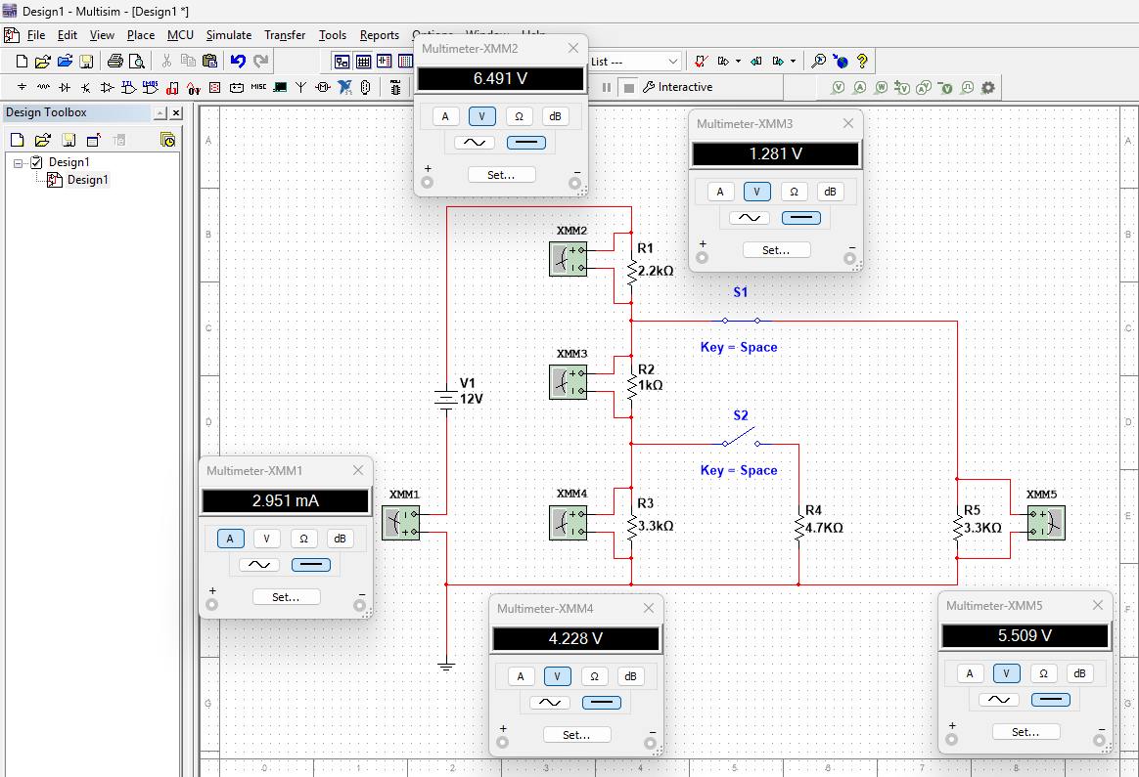
Figure 3. Voltage and Current readings when SW1 is closed.
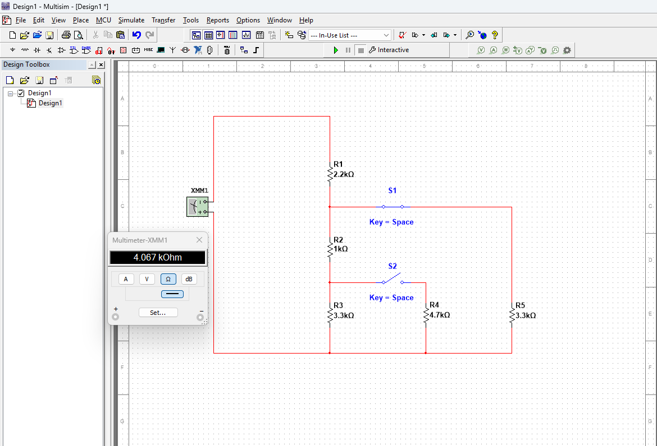
Figure 4. Resistance reading when SW1 is closed.

(c) SW1 and SW2 closed
With both switches SW1 and SW2 closed, the circuit experiences further changes in total resistance and current paths, because R3 and R4 are in parallel, in series with R2, which is in parallel with R5, and the combination is in series with R1. The calculated total resistance, branch currents, and voltage drops were verified using Kirchhoff’s laws. Simulation results also match well with the theoretical calculations, confirming the analysis.
- Total resistance in the circuit,
Parallel of $R_{3}$ and $R_{4}$,
$$\frac{1}{R_{34}}=\frac{1}{4700}+\frac{1}{3300}$$
$$\frac{1}{R_{34}}=\frac{3300+4700}{3300×4700}$$
$$R_{34}=\frac{3300×4700}{3300+ 4700}$$

$R_{34}$=1.94 kΩ
Series of $R_{2}$+parallel of $R_{3}$ and $R_{4}$,
(Consider it as branch 2)
$R_{branch2}$=$R_{2}+R_{34}$
=1+1.94
=2.94 kΩ
Parallel of $R_{5}$ and branch 2,
$$\frac{1}{R_{A-ground}}=\frac{1}{R_{5}}+\frac{1}{R_{branch2}}$$
$$\frac{1}{R_{A-ground}}=\frac{1}{3.3}+\frac{1}{2.94}$$
$$\frac{1}{R_{A-ground}}=\frac{3.3+2.94}{3.3×2.94}$$
$$R_{A-ground}=\frac{3.3×2.94}{3.3+2.94}$$
=1.55 kΩ
Addition of $R_{1}$ in series,
$R_{t}$ = $R_{1}$+$R_{A-ground}$
=2.2+1.554
=3.754 kΩ
- $I_{t}=\frac{V}{R_{t}}$
=$\frac{12}{3754}$
=0.0032 A
=3.2 mA
- Volt drops,
across $R_{1}$,$V_{1}$=$R_{1}×I_{t}$
=3.2$×$2.2
=7.04 V
Node A voltage (after $R_{1}$),$V_{A}$=12–7.04
=4.96 V
Branch currents from node A,
Through $R_{5}$,$I_{5}=\frac{V_{A}}{R_{5}}$
=$\frac{4.96}{3.3}$
=1.51 mA
Through $R_{2}$ branch,$I_{2-branch}$=$\frac{V_{A}}{R_{2}+R_{34}}$
=$\frac{4.96}{2.94}$
=1.69 mA
Voltage at node B after $R_{2}$,
$V_{B}$ = $V_{A}$– ($I_{2-branch}×R_{2}$)
=4.96 – (1.69$×$1)
=4.96–1.69
=3.27 V
Currents in $R_{3}$ and $R_{4}$,
$I_{3}$=$\frac{V_{B}}{R_{3}}$
=$\frac{3.27}{3.3}$
=0.99 mA
$I_{4}$=$\frac{V_{B}}{R_{4}}$
=$\frac{3.27}{4.7}$
=0.7 mA
Checking if the values are right,
$I_{3}$+$I_{4}$=0.99+0.7
=1.69 mA (matches the $I_{2-branch}$)
- KCL at node A,
$I_{t}$=$I_{5}$+$I_{2-branch}$
3.2=1.51+1.69
=3.2 mA
KVL in the main loop,
V1+Voltage drops across branch=7.04+4.96
=12 V
Hence proved.

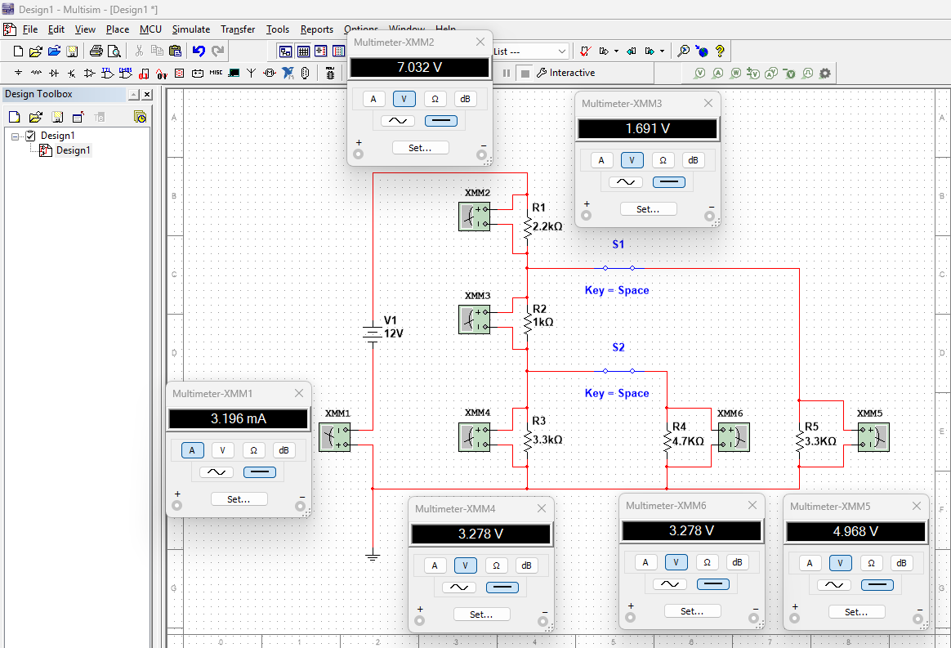
Figure 5. Voltage and Current readings when SW1 and SW2 are closed.
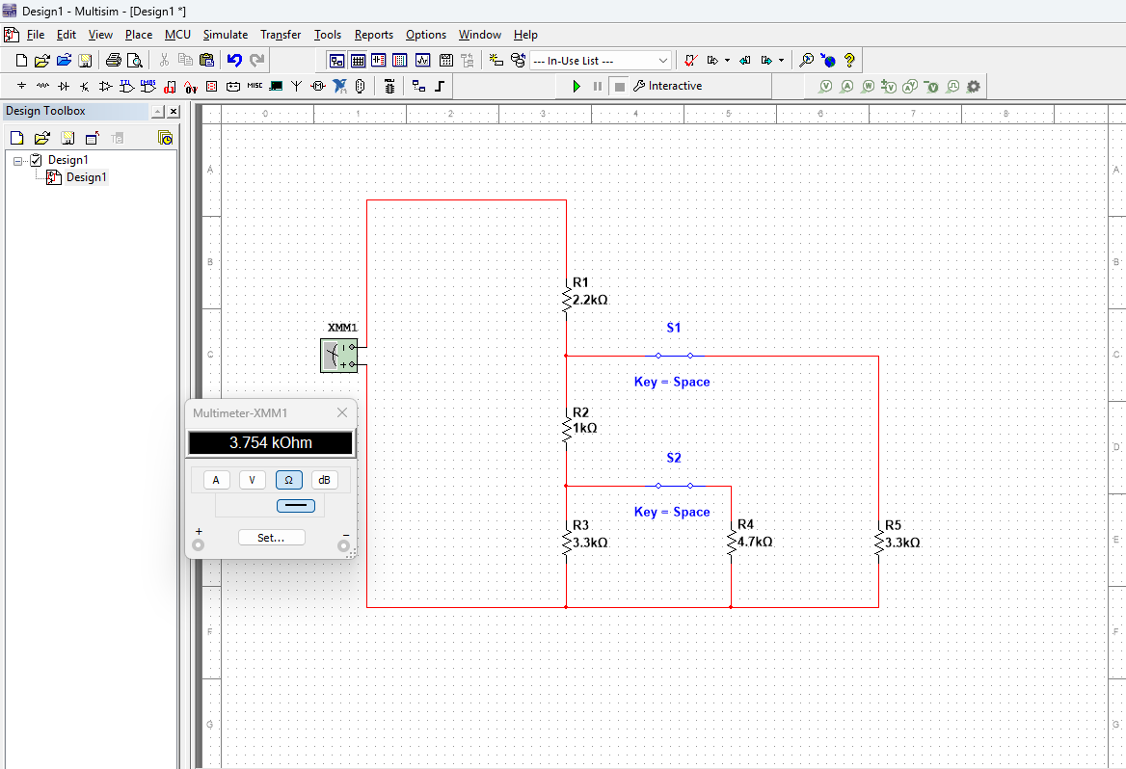
Figure 6. Resistance reading when SW1 and SW2 are closed.

Task 2
Series combination $R_{4}\&R_{5}$,
$$R_{45}=R_{4}+R_{5}$$
=1k + 3.3k
=4.3 kΩ
Reducing Parallel Section$\left(R_{3}||\left(R_{4}+R_{5}\right)\right)$,
$${R_{p}=R}_{3}||R_{45}$$
$$\frac{1}{R_{p}}=\frac{1}{R_{3}}+\frac{1}{R_{45}}$$
$$R_{p}=\frac{R_{3}R_{45}}{R_{3}+R_{45}}$$
$$R_{p}=\frac{6k×4.3k}{6k+4.3k}$$
$$R_{p}=\frac{25.8}{10.3}$$
$$R_{p}=2.505 kΩ$$
Total Circuit Resistance,
$${R_{total}=R}_{1}+R_{2}+R_{p}$$
$$R_{total}=3.3k+5k+2.505k$$
$$R_{total}=10.805 kΩ$$
Total Current from Supply,
$$I_{total}=\frac{V}{R_{total}}$$
$$I_{total}=\frac{9}{10.805k}$$
$$I_{total}=0.833 mA$$
Voltage at Node A (across $R_{3}\&R_{45}$),
$${V_{A}=I}_{total}×R_{p}$$
$$V_{A}=0.000833×2505$$
$$V_{A}=2.087 V$$
This is the voltage across $R_{3}$
Current through $R_{3}$,
$$I_{R3}=\frac{V_{A}}{R_{3}}$$
$$I_{R3}=\frac{2.087}{6000}$$
$$I_{R3}=0.000348 A=0.348 mA$$
Power dissipated in $R_{3}$,
Formula used, $P=I^{2}×R$
$$P_{R3}={(0.000348)}^{2}×6000$$
$$P_{R3}=0.000726 W=0.726 mW$$

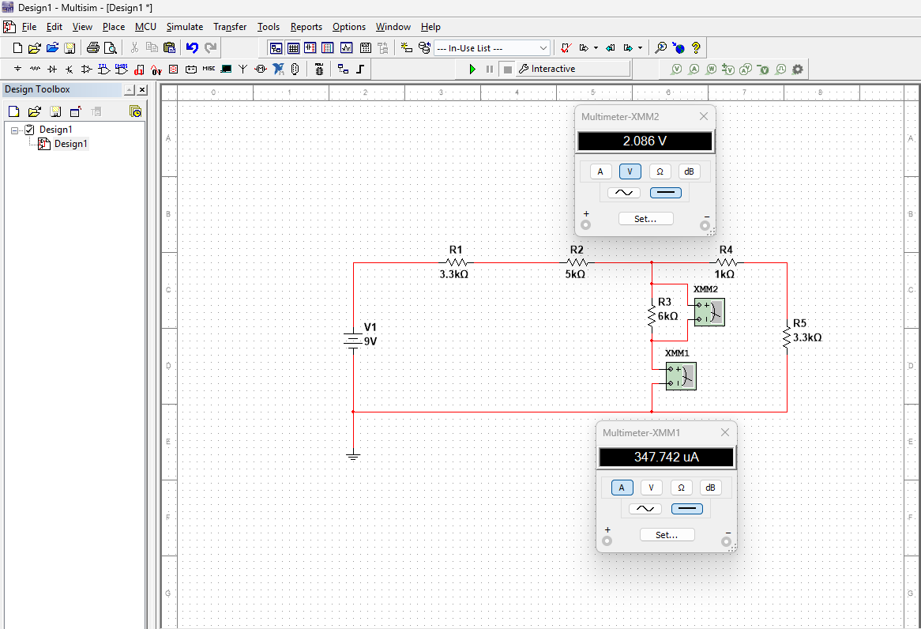
Figure 7. Voltage and Current readings.
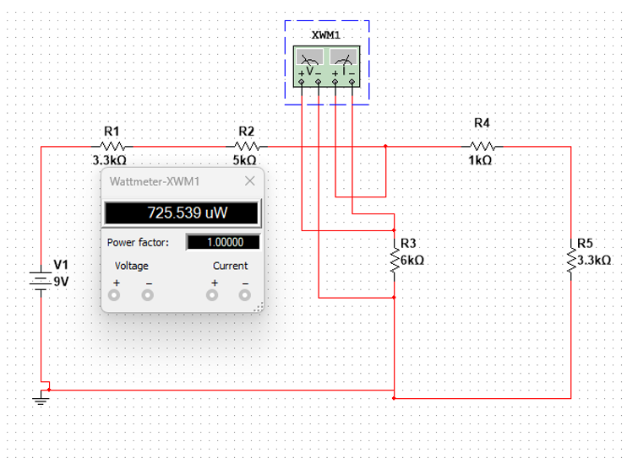
Figure 8. Wattage Rating.

Conclusion
Analysing the two DC circuits using Ohm's law and Kirchhoff's current and voltage laws provided an understanding of how resistors perform under different switching conditions. The calculations with total resistance, current distribution, and voltage drops showed that opening and closing switches changed the paths in the circuit, accordingly, changing the current flow and power dissipation across individual components. Simulation results confirmed the closeness of theoretical calculations to the methods used. Task 2 determined the current and power rating for R3, emphasizing the need for appropriate component wattage that ensures safety and reliability in circuits. In general, this also strengthened the knowledge of the series-parallel resistor circuits and showed how fundamental electrical laws apply to practical circuit analysis.

Overall Conclusion
The shift from fossil fuel-centred energy systems to renewable energy systems transforms the concept of energy security, and extends it beyond fuel availability to include resilience, flexibility, cyber security, and social equity. According to IRENA (2024) and UK Energy in Brief (2024), this report demonstrates that while renewable energy reduces the geopolitical reliance on fossil fuel exporters and enables more domestic energy generation, it also introduces new vulnerabilities related to critical mineral supply chains, grid interconnections, and climate exposure. Increased electrification, cross-border electricity trade, and the development of green hydrogen alter the global power structures, and they demand enhanced international cooperation and policy reforms in engineering principles.
The thematic analysis indicates that future Energy Security depends on resilient infrastructures, flexible grid systems, and equal access, with national priorities, like those in the UK. The analysis of the DC circuit supports these themes at an engineering level, illustrating how accurate the theoretical calculations verified by simulation are essential for ensuring the reliability and stability of systems. Ultimately, the results confirm that secure energy systems in the era of renewable energy require the integration of engineering principles, coordinated policy measures, and international collaboration to create a sustainable, reliable, and resilient energy network solution.

References
- https://www.plymouth.ac.uk/discover/what-is-energy-security
- https://www.irena.org/-/media/Files/IRENA/Agency/Publication/2024/Apr/IRENA_Geopolitics_transition_energy_security_2024.pdf
- https://researchbriefings.files.parliament.uk/documents/POST-PN-0676/POST-PN-0676.pdf
- https://www.oecd.org/content/dam/oecd/en/publications/reports/2020/12/projected-costs-of-generating-electricity-2020_9f0efddc/a6002f3b-en.pdf?utm_source=chatgpt.com
- https://assets.publishing.service.gov.uk/media/687f4cf592957f2ec567c64f/UK_Energy_in_Brief_2024.pdf

